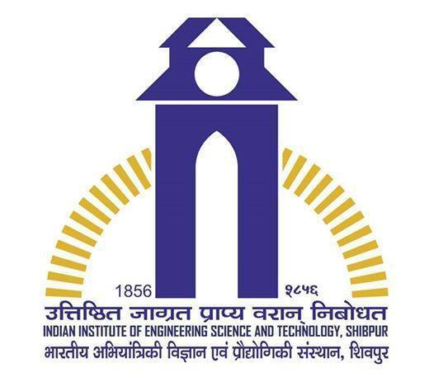

**Rajat Kumar Agarwal**

B.E. 3rd year ,

|  |
| --- |
| Information Technology |
| Indian Institute of Engineering ,  Science and Technology,  Shibpur,Howrah-711103 (WB)  Contact: 7209286765  Email:agarwal.rajat.72@gmail.com |  |

. iiests.ac.in

**Objective**

To gain knowledge and do research related works such that using of skills in right direction.

**Academic Details**

|  |  |  |  |  |
| --- | --- | --- | --- | --- |
|  | **Year Of Passing** | **Qualification** | **School/College** | **Percentage/CGPA** |
|  | 2017 | B.Tech | Indian Institute of  Engineering , | 8.03/10 |
|  | (currently in . --3rd year ) |  | Science and Technology ,  Shibpur. | (current) |
|  |  |  |  |  |
|  | 2013 | Class XII(CBSE) | Chinmaya Vidhyalaya | 92% |
|  | AISSCE | Bokaro,  Jharkhand |  |
|  |  |
|  | 2011 | Class X(CBSE) | D.A.V Public School | 10/10 |
|  | AISSE | Moonidih,Dhanbad,  Jharkhand |  |
|  |  |
|  |  |  |  |  |

**Skills**

* Programming Languages: C, C++,Core JAVA.
* Data Structure,Assembly language(8085), Basic HTML.
* Database:Excel,SQL,Oracle.
* Platforms: Linux- Ubuntu,Windows.
* Language :English, Hindi, Marwari.

**Hobbies and interest**

* Coding and Debugging.
* Playing chess,cricket and games
* Web designing and Ethical Hacking.
* Swimming,Rubix cube,Mirror cube and Guitar.

**Achievements**

* Congratulation letter from Kapil Sibal, Minister of Human Resource Management ,Government of India .
* Recieved Merit Scholarship of Rs12,000 from GAABESU .
* City topper, AIR-261 ,Merit Certificate ,National Cyber Olympiad.
* Merit Certificate in Physics, CHINMAYA VIDYALAYA,BOKARO.
* Merit Certificate in ‘Arya Vidya Sabha-Sanskrit Exam’ 2006 -2007.
* Merit Certificate for 3rd Topper in School.
* Merit Certificate from CARRER POINT.
* Proficiency Certificate from CBSE.

**Extra Curricular Activities**

* Attended Workshop on "ETHICAL HACKING" conducted by TECH DEFENCE.
* Attended Workshop on “Cloud Computing” organised by ‘IIT Kharaghpur'.
* Attended Workshop on “GLOBAL ENTERPRENEURSHIP SUMMIT” organised by ‘IIT Kharaghpur'.
* Project on website design of Ramanujan Library using Html,Javascript in evevt instruo'15 organized by IIEST,Shibpur.

**Relevant Courses**

* Programming in C,C++, core JAVA, basic HTML,Data Structure,RDBMS,Operating System,Computer Graphics, Automata Theory, Computer Organization and Architecture, Microprocessor(8085).

**Personal Details**

* Name: Rajat Kumar Agarwal
* Father’s Name: Mr. Ashok Kumar Agarwal
* D.O.Birth.: 24th-oct-1995
* Address of communication: S/o. Ashok kumar Agarwal,Hno.-37

Kendua Bazar ,Dhanbad .pin-828116(Jharkhand).

**Declaration**

* I hereby declare that all the details furnished above are true and

valid to the best of my knowledge.

**Place**:IIEST ,shibpur **Date**:20.03.2016